HandloomHub: Empowering Artisans to Thrive Through Product Management, Sales Insights, and Event Engagement
1.K.Midhun Kumar, 2.D.Narasimha Rao, 3.Akash.S, 4.S.Siva Anjaneyulu, 5.G.Sunil Kumar
Dr.Zafar Ali Khan N

Abstract
We aim to transform the lives of rural artisans through a user-friendly platform connecting their cultural heritage to a global audience. Artisans can register, upload product listings like textiles and handicrafts, and access sales analytics to refine their offerings. The platform supports collaboration via events such as workshops and exhibitions, fostering a sense of community. Trust is built through initial Cash on Delivery payment options, ensuring secure transactions.
Features like “Artisan of the Month” enhance visibility, while dedicated sections for government schemes and updates provide growth opportunities. By telling the story behind each product, the platform celebrates craftsmanship, preserves cultural traditions, and supports sustainable livelihoods in the digital economy.

I. Introduction
The Handloom Hub project aims to transform the lives of rural artisans by creating a dynamic online platform designed to showcase and sell their unique handicrafts. This platform serves as a bridge between the artisans' rich cultural heritage and a global urban audience eager to experience authentic craftsmanship. By offering a space where artisans can easily register, upload detailed product listings, and access valuable sales analytics, we empower them to better understand customer preferences and market trends.
Our platform fosters a sense of community by enabling artisans to participate in collaborative events such as exhibitions, workshops, and festivals, ensuring transparent communication and building a supportive environment. To foster trust in online transactions, we implement Cash on Delivery (COD) payment for new users, ensuring a secure and reliable shopping experience.
In addition, the Handloom Hub platform celebrates the remarkable contributions of artisans through initiatives like the "Artisan of the Month," offering them increased visibility. Artisans also benefit from a dedicated section with updates on government schemes, events, and exhibitions, providing them with opportunities to expand their businesses and connect with industry leaders.
Through this project, our mission goes beyond facilitating the sale of products. We aim to tell the stories behind each creation, highlighting the skills, traditions, and passions of rural artisans. By connecting their craftsmanship with urban consumers, we seek to preserve cultural heritage, promote sustainable livelihoods, and provide artisans with the tools they need to thrive in an increasingly digital world.
II. LITERATURE REVIEW
- Existing Methods
The existing platforms for promoting artisanal products reveal several innovations but also significant limitations:
- General E-commerce Platforms: Early initiatives like the "Online Handicrafts Store" focused on providing a simple marketplace for handicrafts but lacked specialization for handloom products and artisan-specific features such as cultural storytelling or product analytics.
- AI-Driven Platforms: The "E-Commerce Website for Artisans" incorporated AI for demand forecasting and product recommendations. While this enhanced customer interaction, the complexity and cost of such systems made them less accessible to small-scale artisans in rural areas.
- Community-Oriented Platforms: "HandCraft Hub" and "Artisan Connect" emphasized collaboration among artisans and community building through forums and group projects. However, they lacked sufficient technical support and tools for artisans unfamiliar with digital platforms.
- Cultural Storytelling Platforms: Projects like "Tradition Threads" and "Local Looms" focused on highlighting cultural heritage and weaving techniques, helping customers understand the unique value of products. Yet, these platforms were often limited in scalability and primarily targeted niche markets.
- Dynamic User Interfaces: The integration of modern technologies like AR for virtual product previews was seen in platforms like "Artisan Connect." While innovative, such features were resource-intensive and inaccessible for most rural artisans.
Research Gaps:
Current platforms for rural artisans leave significant areas unaddressed, creating opportunities for improvement:
- Event Management: Limited tools exist for organizing exhibitions, workshops, and live showcases, which are crucial for artisan visibility and networking.
- Handloom-Specific Features: Platforms fail to highlight unique aspects of handloom products, such as weaving techniques and cultural narratives.
- Business Analytics: Artisans lack access to data insights on customer behavior and product performance, restricting their ability to make informed decisions.
- Secure Payment Options: Few platforms offer trusted payment systems tailored to the needs of rural artisans and customers.
- Interactive User Experience: Static interfaces do not foster meaningful connections between customers and artisans, reducing engagement.
- Scalability: Existing platforms seldom provide tools to help artisans expand beyond local markets to global audiences.
- Cultural Storytelling Integration: The absence of storytelling features reduces the emotional connection between artisans and customers.
III. PROPOSED METHODOLOGY
The HandloomHub methodology is designed to ensure a seamless user experience, robust functionality, and scalable operations.
  - Problem Analysis
Conduct field studies and interviews with rural artisans to understand their needs and barriers to market entry.
Identify gaps in existing platforms and define objectives aligned with artisans' growth and empowerment.
  - Architectural Design
- Frontend: Develop an interactive and culturally rich user interface using React.
- Backend: Leverage Django to build a modular architecture, enabling scalability and easy feature integration.
- Database:
Implement MySQL/PostgreSQL for secure and efficient data storage.
- Payment Gateway:
Integrate Razorpay/Stripe with phased payment options, including COD for new users.
3.3 Key Functional Modules
- Artisan Registration and Management:
Simple onboarding process with minimal technical requirements.
Dashboards offering real-time analytics on sales, inventory, and customer preferences.
- Product Showcasing and Storytelling:
Detailed product pages with high-quality images and descriptions highlighting weaving techniques and cultural heritage.
- Event Management System:
Tools for creating, managing, and promoting events such as exhibitions and craft fairs.
Event notifications and calendars integrated into artisan dashboards.
- Advanced Analytics:
AI-driven insights for demand forecasting, sales trends, and seasonal preferences.
- Secure Transactions:
Multi-tiered payment systems with gradual access to online payment methods post-COD adoption.
Fraud prevention measures and transaction tracking for customer and artisan safety.
3.4 Development Workflow
- Sprint-Based Agile Development: Ensure iterative delivery and quick feedback loops.
- Testing:
Unit and integration testing to validate core functionalities.
Conduct load testing to evaluate the system's performance and reliability under conditions of high user traffic.
Usability testing with artisan focus groups.
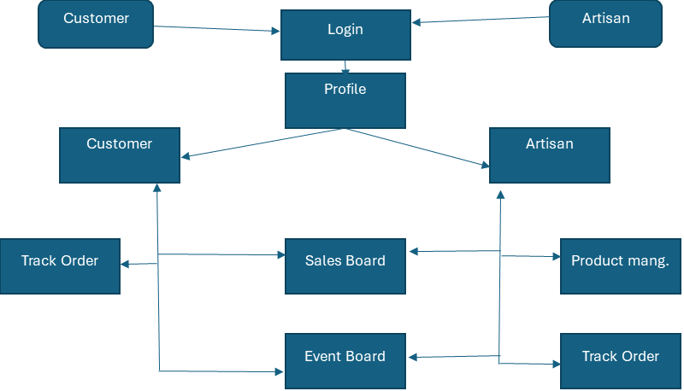
The system has two primary user roles: Customer and Artisan. Role-based access control is implemented to manage user permissions. The architecture is modular, with distinct components like "Login," "Profile," etc.

IV. OBJECTIVES
Develop an online platform connecting rural artisans with urban consumers to showcase and sell handicraft products. The platform addresses challenges like limited market access and business tools, promoting economic growth, cultural preservation, and community engagement.
1.Artisan Registration & Product Upload:
- Simple registration and product upload with detailed descriptions and high-quality images.
- Product categorization for better discoverability.
2.Sales Tracking & Dashboard:
  - Personalized dashboards with sales insights, inventory alerts, and customer feedback.
  - Visual analytics for tracking trends and optimizing offerings.
3.Community Building:
  - Forums and events for collaboration, skill-sharing, and joint projects.
  - Transparent contributions to build trust and foster growth.
4.Artisan Visibility:
  - Highlight artisan stories and seasonal collections.
  - Marketing tools and partnerships to expand reach.
5.Sustainability & Long-Term Impact:
  - Secure payments (including COD), access to government schemes, and educational resources.
  - Preserves cultural heritage and drives rural economic development.
V. ARCHITECTURE
The architecture of the platform is designed to efficiently support the needs of artisans, customers, and administrators while ensuring scalability, security, and user-friendliness. Here is a concise summary of the architecture:
1. High-Level Architecture
Frontend Technologies: React.js
Purpose:
  - Build responsive and dynamic user interfaces.
  - Interact with backend APIs for features like registration, product upload, dashboards, and purchases.
Key Features:
  - User authentication flows (login, registration).
  - Artisan and customer dashboards.
  - Dynamic search and filtering for products.
Backend Technologies: Express.js with Node.js.
Purpose:
  - Handle API requests and responses.
  - Manage business logic, user authentication, and integrations with third-party services.
Key Features:
  - Modular structure for scalable code (using MVC or service-based architecture).
  - RESTful API endpoints for user management, product management, sales tracking, and analytics.
  - Incorporate middleware to manage request validation, user authentication, and efficient error handling
Database
- NoSQL Database:
MongoDB for unstructured data like product images and artisan stories.
Implementations
1. Development Environment Setup
- Install Necessary Software:
  - Node.js: Required for backend development with Express.js (if using JavaScript) and frontend tools like React.
  - React: Utilized for creating a responsive and dynamic user interface with modern design principles.
  - Database Management Tools: MySQL Workbench or pgAdmin for managing and visualizing database schemas.
- Development Tools:
Install IDEs like Visual Studio Code for code development with plugins for linting, debugging, and formatting.
- Environment Configuration:
Create .env files for managing sensitive information like API keys, database credentials, and secrets

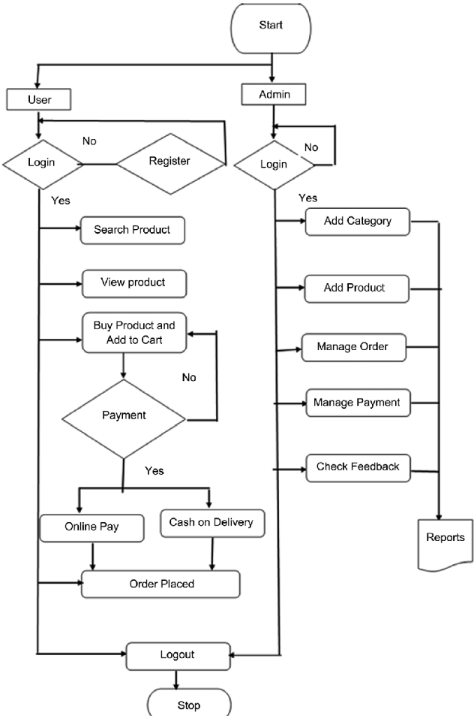
The image is a flowchart depicting the workflow of Handloom Hub. It outlines the actions for both users customer and Artisan. Users can register, login, search products, view details, and make payments (online or cash on delivery). Artisan have additional functionalities products, managing orders and payments

2. Frontend Development
- Responsive Design:
Use Bootstrap or TailwindCSS to ensure the platform is mobile-friendly, catering to users on budget smartphones and tablets.
React Integration:
Develop the user interface by dividing it into modular components like navigation menus, product displays, user dashboards, and input forms. Implement React Router to enable seamless navigation within a single-page application (SPA) for an enhanced user experience.
3. Backend Development
- API Development:
Use Express.js for creating RESTful APIs to handle operations like user registration, product uploads, and sales tracking.
Design endpoints with clear and consistent naming conventions (e.g., /api/v1/products, /api/v1/orders).
- Authentication and Authorization:
Implement secure user authentication using tools like Firebase Authentication or JWT (JSON Web Tokens).
Include role-based access control (RBAC) to differentiate permissions for artisans, customers, and admins.
- Payment Processing:
Integrate payment gateways like Razorpay or Stripe to handle online transactions.
Include support for Cash on Delivery (COD) for customers new to online shopping, enhancing trust.
4. Database Integration
- Schema Design:
Define tables for users, products, sales, events, and analytics.
Use relational database features like foreign keys to establish relationships between tables (e.g., linking products to artisans).
- Performance Optimization:
Index frequently queried fields (e.g., product categories) to improve search performance.
Use database views for pre-computed analytics, such as top-selling products or active artisans.
- Backup and Security:
Configure automated backups to prevent data loss.
Use encryption for sensitive data like passwords and payment information.
5. Testing
- Unit Testing:
Test individual components and endpoints to ensure they function as expected.
Use testing frameworks like Jest (for frontend) and Mocha (for backend).
- Integration Testing:
Verify the interactions between different components (e.g., frontend forms submitting data to the backend).
- Performance Testing:
Test the application on low-end smartphones and slow internet connections to ensure usability in rural areas.
6. Long-Term Improvements
- Feature Enhancements:
Add a real-time notification system for orders, stock alerts, and event participation using tools like Socket.IO.
Implement advanced search features using Elasticsearch for better product discoverability.
- User Feedback Loop:
Collect feedback from artisans and customers to refine the platform's features.
Use surveys or analytics tools to understand user behavior and improve the user experience.
- Partnerships and Outreach:
Collaborate with local organizations or government bodies to onboard artisans.
Run marketing campaigns to promote the platform among urban consumers.

VI. OUTCOMES
1. Increased Visibility for Artisans
The platform connects rural artisans with a wider audience, giving them exposure to urban customers and beyond. It highlights their unique crafts, ensuring visibility and appreciation for their talent.
2. Enhanced Sales Opportunities
Artisans gain direct access to a digital marketplace, bypassing middlemen, which allows them to reach more customers, expand their market reach, and increase their revenue potential.
3. Empowerment and Economic Growth
By providing tools for managing sales, showcasing products, and accessing data insights, the platform empowers artisans to take charge of their businesses, leading to sustained economic growth.
4. Community Building and Engagement
Features like forums and collaborative events foster a strong sense of community among artisans, encouraging mutual support, knowledge sharing, and joint initiatives.
5. Recognition of Artisans
Special initiatives like "Artisan of the Event" awards and promotional features celebrate artisans' contributions, boosting their morale and reputation within their community and among customers.
6. Data-Driven Insights
Personalized dashboards offer artisans valuable analytics on sales, product performance, and customer preferences, helping them make informed decisions to grow their businesses.
7. Increased Participation through Events
The platform organizes events, workshops, and exhibitions, encouraging artisans to actively participate, showcase their talents, and build their network, fostering greater engagement and collaboration.
VII. CONCLUSION
This project focuses on developing an intuitive and accessible digital platform to bridge the gap between rural artisans and a broader market, enabling them to showcase and sell their handloom and textile products. By integrating features like personalized dashboards, artisans can track their sales, earnings, and product performance, while streamlined product management tools allow them to easily upload and categorize their offerings. The platform also fosters community engagement by facilitating event participation and collaboration among artisans, creating opportunities for networking and growth. Secure order tracking and payment systems ensure a seamless customer experience, making it easier for buyers to access unique, handcrafted items while supporting traditional craftsmanship. Ultimately, the project aims to preserve cultural heritage, empower artisans economically, and provide them with the recognition and opportunities needed to thrive in a competitive market.
ACKNOWLEDGMENT
The authors would like to acknowledge the support of Presidency University for providing resources and facilitating this research project. We are also grateful to the university librarians, professors, and research assistants for their assistance.
REFERENCES
- Aabha Patil, Ritu Shailendra Jha, Ritu Raju Jha, Nandini Vijay Gurav, “EPICRAFT – WEBSITE FOR ARTISANS”,IJSRCSEIT November 2022
- Amisha Shah, Rajev Patel, “E-COMMERCE AND RURAL HANDICRAFT ARTISANS”, Voice of Research 5(3) December 2016 24-29
- .Raghavendra P, Sahana H S, Prasad M D, Srinidhi Kulkarni, G V Bhavana-Commerce Website for Artisans, International Journal of Research Publication and Reviews, Vol 4, no 5, pp 4152-4156 May 2023
- Tannistha Pal, HandCrafted: An Online Shopping Website of Handicratfs, February 2021 Journal of Physics Conference Series 1804(1):012079
- Nidhi Mantri, Sheetal Sharma, Nitesh Kumawat, Hasnain Abbas Tinwala, KartikeyBharti, Charu Kavadia, E-Commerce Web Application for Local Artisans, International Advanced Research Journal in Science, Engineering and Technology 10(2), May 2023
- Pranav Kumar, Sneha Reddy, Kavya Menon, “Unspoken Craft: E-commerce Site for Handlooms and Handicrafts,” International Journal of Innovative Technology and Exploring Engineering (IJITEE), Vol. 9, Issue 11, March 2024.
- Avinash Rao, Meera Shukla, “CraftKart – Promoting Handmade Products through E-Commerce,” Journal of Advanced Research in Computer Science and Applications (JARCSA), Vol. 7, Issue 4, July 2023, pp. 53-60.
- Kavita Sharma, Rohit Kumar, “Artisan Connect: A Digital Platform for Artisans,” International Journal of Artificial Intelligence and Applications (IJAIA), Vol. 11, No. 2, April 2024.
- Divya Narayanan, Arjun K, “Local Looms: A Platform for Regional Handlooms,” Journal of Textile Engineering and Fashion Technology (JTEFT), Vol. 5, Issue 3, October 2023.
- Aishwarya Gupta, Sanjay Kumar, “Artify: Empowering Artisans through Digital Platforms,” International Journal of Computer Applications (IJCA), Vol. 180, Issue 4, December 2022.

